UNITED WAY OF BOONE COUNTY ILLINOIS Individual Pledge Form
Please complete in full to have your gift appropriately acknowledged.
1 | DONOR INFORMATION This information will not be shared I/We wish to remain anonymous
First Name |  |  | MI |  |  |  |  |  |  | Last Name
Address |  |  |  | City |  |  |  |  |  |  |  |  | State |  | Zip
Preferred Phone |  |  |  | Preferred Email
2 | AMOUNT AND PAYMENT METHOD – Choose Option A or B
Option A: Payroll Deduction |  |  |  |  | Option B: One Time Contribution
I wish to give through payroll deduction. |  |  |  |  | Amount  $ |  |  |  |  |  | Stock or Endowment (Contact United Way)
$ per pay period |  |  |  |  |  |  |  |  |  |  | Check # Date
X # of pay periods |  |  |  |  |  |  |  |  |  |  | (Payable to United Way of Boone County)
= Annual Gift Total |  |  |  |  |  |  |  |  |  |  | Bill Me : Once Quarterly
 |  |  |  |  |  |  |  |  |  |  | PayPal (Give online at www.uwboonecounty.org/give )
3 | CHOOSE HOW YOU WISH TO INVEST IN YOUR COMMUNITY
Option A: United Way of Boone County Community Impact Fund |  |  |  |  |  |  |  | Option B: Restricted Contribution
The most powerful way to invest your contribution! Volunteers and staff study community needs and meet with every agency applying for funding to ensure informed decisions are made before investing your contribution locally. |  |  |  |  |  |  |  | I wish to designate my contribution to another United Way.  United Way  Address  City, State, Zip
4 | SIGN AND DATE PLEDGE FORM – Signature is required for all pledges
DAE FORM - or all pledges
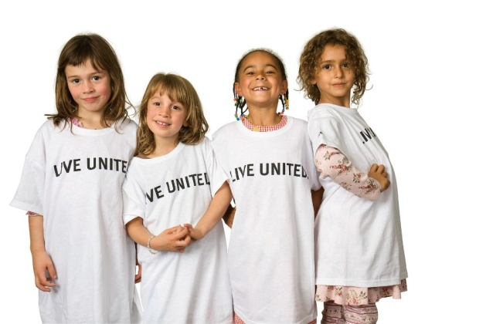
Please print completed form, sign and date.

Signature Date

THANK YOU FOR YOUR CONTRIBUTION!
No goods or services were provided in exchange for this contribution. Please keep a copy of this form for your tax records. You will also need a copy of your pay stub, W-2 or other employer document showing the amount withheld and paid to a charitable organization. Consult your tax advisor for more information.

